Just confirming that you will be doing the work, as below, on our VS1 Cloud package web site <https://vs1cloud.com.au/index.php> using Javascript, bootstrap, MeteorJS.

This job is a simple connection of an email system to our existing screens and setup in VS1

The data will come from an API call, to a TrueERP backend database, using the built in TrueERP REST <http://www.trueerp.com/wiki/Web_API/>

You will be provided with full access to a remote machine, with TrueERP running on it, for testing and given full login details to VS1 Cloud, also for testing. <https://sandbox.vs1cloud.com/>

Start date would be immediately.

Login to VS1 Cloud

Use the following credentials to log in:  
Email:  
Password:

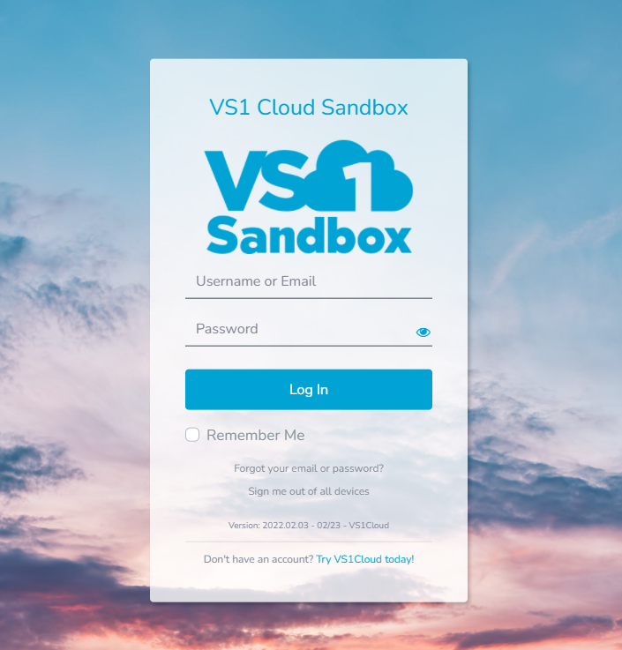

Note before starting:

The handling of email’s being sent will be done in VS1 Cloud. (Not TrueERP)

Application to handle this will be Laravel <https://laravel.com/>

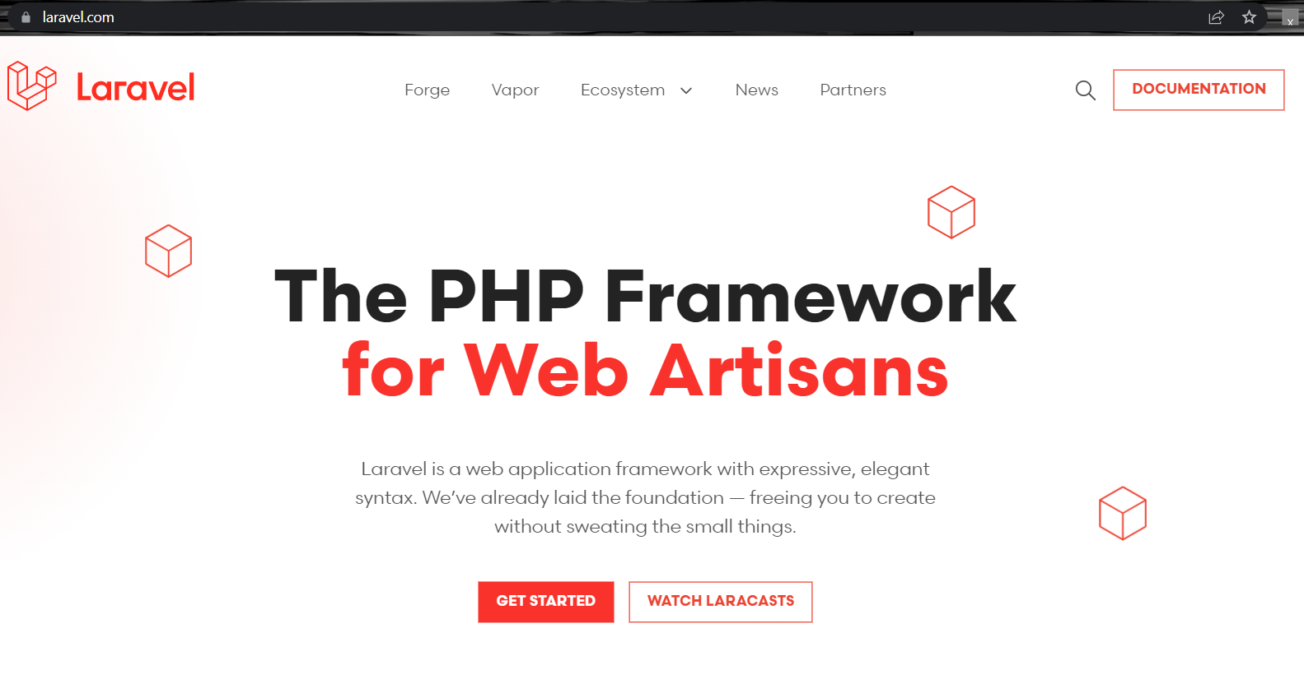

Navigate to and click on Settings  
  
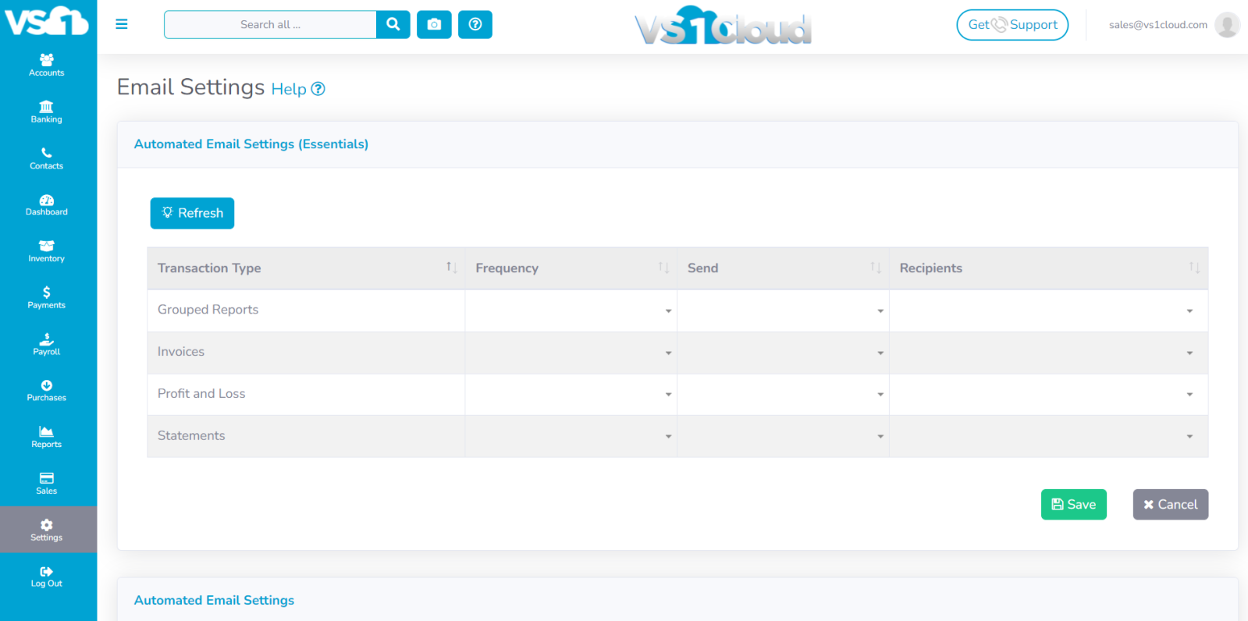  
  
Clicking on Grouped Reports box will open a list of reports to add to this group

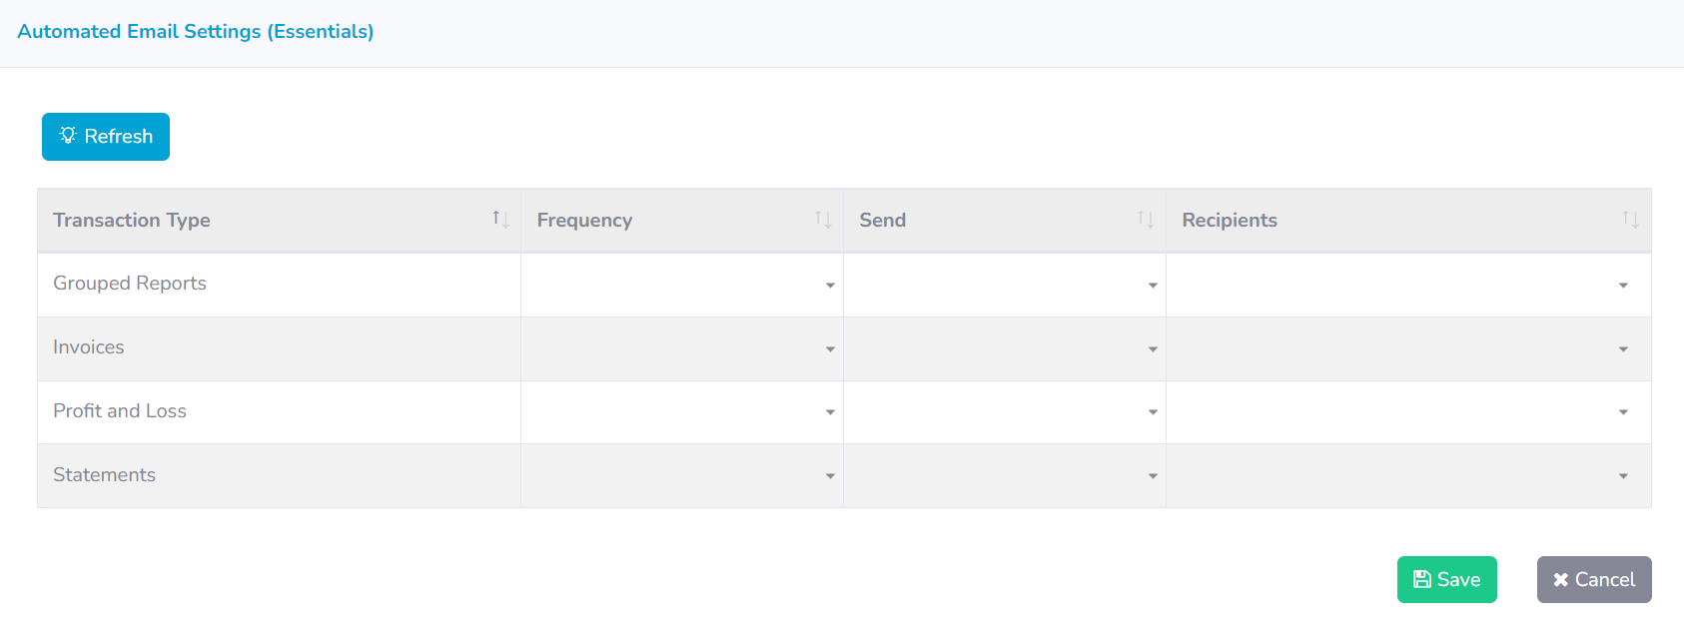

Select by clicking the Star to add to grouped reports. This will be different from "Add to Favourites"

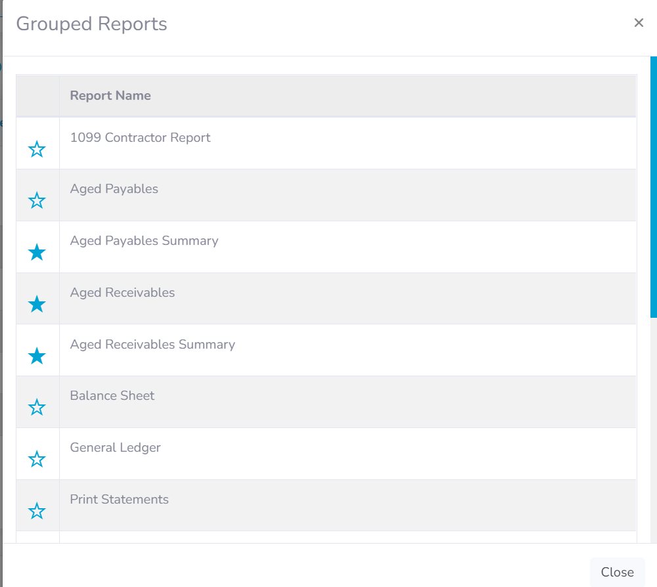

Select Frequency dropdown

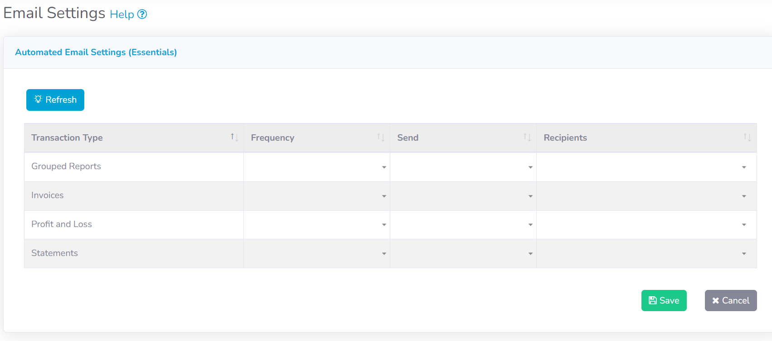

This option shows options for the Month. Select a day of the month from the Every Day dropdown. Select a month from the Of Month(s) tixck box’s. Select a Start Time and then select a Start Date. This then sets the date and time for the reports to automatically be sent out.

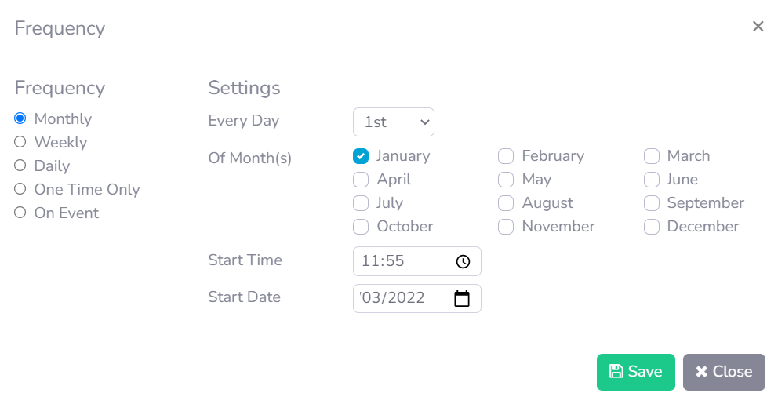

This option shows options for the Week. Select a day of the week from the Select Days tick Box’s. Select the interval of weeks from Every / Week section. Select a Start Time and then select a Start Date. This then sets the date and time for the reports to automatically be sent out.

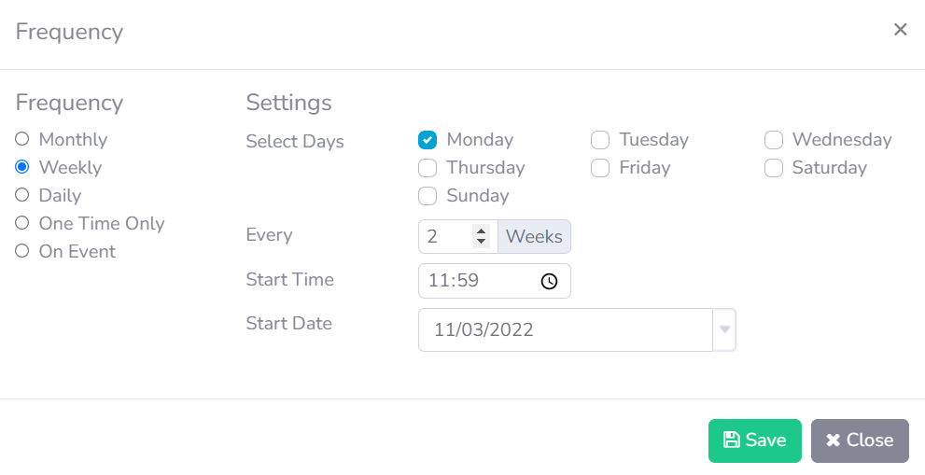

This option shows options for the Day. Select Every Day or Weekdays to post for those particular days. You could also select Every option which will allow you to put in the number of days. Then select a Start Time and Start Date to start sending the reports

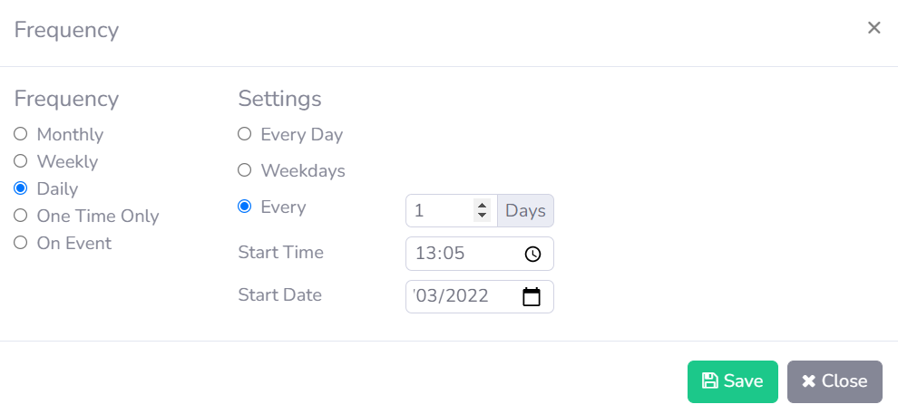

This is a One Time Only event. Select a Start Date and Start Time.

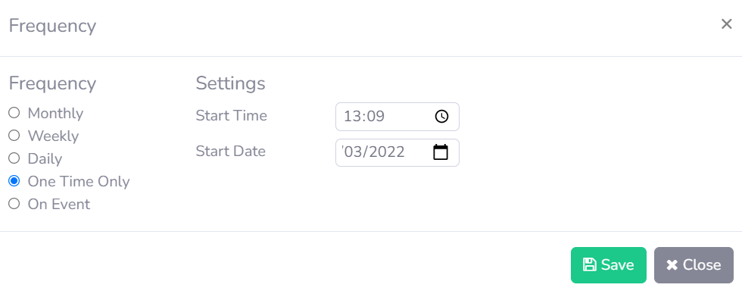

This is a repeat for a Log In or Log Out Event. Select radio button On Logon or On Logout. Click Save to save.

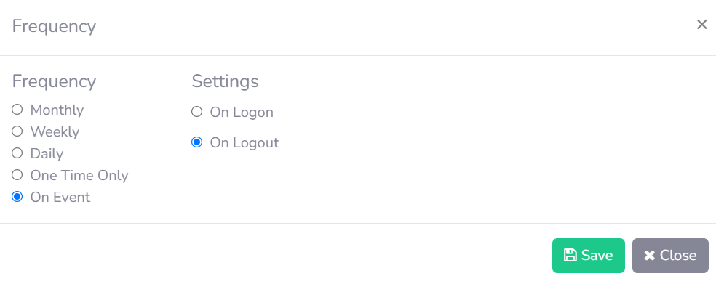

Click Send dropdown



Select one of the radio buttons below to base your “Send” of the reports on or select Date (Should say Time not Date) radio button and enter in a time. Click Save to save.

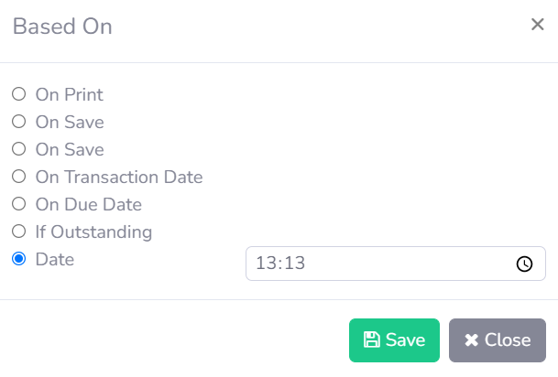

Select Recipients dropdown to add which contact you are sending these scheduled reports too



This will open contacts list. You can select 1, 2, 3 or none of the radio buttons to send to contacts

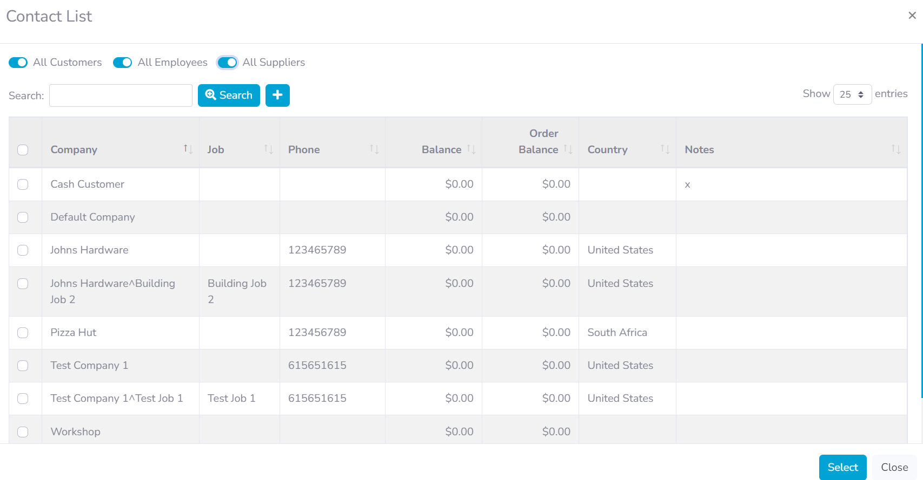

Or you can search for a contact and then select the tick box and click Select

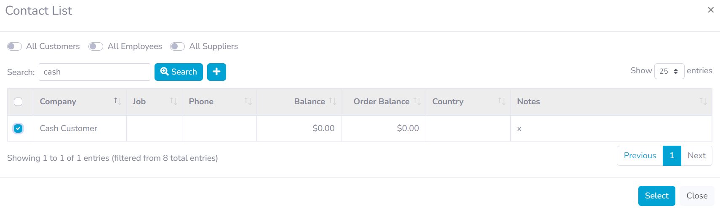

You can also click the + button to create a new contact



Or just select the tick box’s from the list then click Select

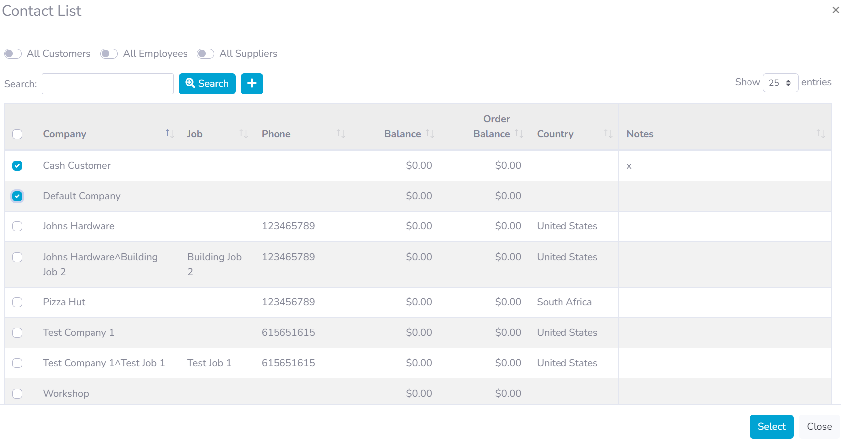

You can also select the amount of entries you wish to show. 25 or All are the options



If you scroll down from the settings screen, there is also an option to schedule all reports separately. The Frequency, Send and Recipients options works the same as above in this document.

